MONEY MENTOR - APP FOR FINANCIAL LITERACY WITH AI INTEGRATION
APP OVERVIEW
The Financial Literacy App with AI Integration is a modern mobile platform designed to help users build strong financial knowledge through interactive learning and intelligent assistance. It combines AI-driven chatbot support, practical financial tools, and structured learning modules to make financial education simple and accessible. The app guides beginners and professionals through essential topics like budgeting, savings, loans, investments, and tax planning. Users can ask real-time questions to the AI chatbot and receive clear, personalized explanations. A set of built-in financial calculators allows users to estimate EMIs and set savings goals. The learning modules follow a level-wise curriculum that gradually increases in complexity to support continuous growth. Its user-friendly interface focuses on clarity, simplicity, and professional visual design. Overall, the app serves as a complete financial literacy companion that empowers users to make confident and informed financial decisions.
MARKET RELEVANCE
- Growing demand for financial literacy as most students and young professionals lack formal financial education and seek easy digital learning platforms.
- Rapid rise of fintech adoption, making people more interested in budgeting, investments, and personal finance management through mobile apps.
- AI-driven guidance is becoming a key trend, and users prefer apps that offer personalized, real-time financial support.
- Increasing financial awareness initiatives by governments and organizations creates a supportive environment for such educational apps.

PROBLEMS IT AIMS TO SOLVE
1. Lack of basic financial knowledge among students and professionals
- Many students and professionals are not taught financial literacy in schools or colleges, so they lack knowledge about saving, investing, and managing money.
- Due to this lack of awareness, they often make poor financial decisions such as unnecessary spending or not planning for future financial needs.
2. Difficulty in understanding complex financial concepts (loans, investments, taxes)
- Financial terms like interest rates, mutual funds, tax deductions, and credit scores are complicated and difficult for beginners to understand.
- Because of this complexity, people may avoid financial planning or make wrong decisions while taking loans or investing money.
3. Poor budgeting and money-management habits leading to overspending and debt
- Many individuals do not track their income and expenses properly, which makes it hard to control their spending.
- Without proper budgeting, people tend to overspend on unnecessary items and may end up in financial debt.
4. Limited access to personalized, reliable financial guidance
- Most people do not have access to professional financial advisors due to high consultation costs.
- As a result, they rely on random online information or advice from others, which may not always be accurate or suitable for their financial situation.
- Confusion caused by scattered information across multiple platforms, making learning inconsistent.

INTRODUCTION
PROBLEM STATEMENT:
Many individuals, especially students and early professionals, struggle with financial decision-making due to a lack of structured financial education. They often face difficulty understanding essential concepts such as savings, loans, investments, and taxes. This knowledge gap leads to poor money management habits, unnecessary debt, and financial stress. Existing information on finance is scattered, complex, and not personalized, making it hard for beginners to learn effectively. Therefore, there is a strong need for an accessible, AI-powered platform that provides clear guidance, practical tools, and interactive learning to improve financial literacy for all users.
PURPOSE:
The purpose of this app is to provide users with an easy and accessible platform to learn essential financial concepts and develop strong money-management skills. It aims to simplify complex topics like budgeting, loans, investments, and taxes through interactive lessons and AI-powered explanations. The app also intends to offer practical financial tools that help users apply their learning in real-life scenarios. Additionally, it seeks to deliver personalized guidance through an intelligent chatbot that adapts to each user’s financial needs. Ultimately, the app’s purpose is to empower individuals to make confident, informed, and responsible financial decisions in their daily lives.
SCOPE:
- The scope of the app covers delivering AI-driven financial guidance that adapts to each user’s knowledge level and provides instant clarity on financial concepts.
- It extends to offering structured learning pathways that help users progress from basic financial awareness to advanced money-management skills.
- The app also includes practical financial tools that enable users to calculate, track, and plan their budgets, investments, savings, and expenses in real time.
- Additionally, it supports secure user data management, allowing individuals to store financial records, monitor their progress, and personalize their learning journey within a protected environment.
GPCU FRAMEWORK
G - GAP ANALYSIS:
- Existing financial education resources are scattered, overly complex, and not designed for beginners, leaving a major gap in accessible and simplified learning.
- Most finance apps offer tools or content separately, but very few combine AI guidance, learning modules, and practical calculators in one integrated platform.
- There is a lack of personalized financial support—users don’t get instant, customized explanations or actionable advice tailored to their financial needs with real-time data.
P-PRODUCT:
- The product is an AI-integrated financial literacy application designed to simplify money management, investments, budgeting, and financial decision-making for users of all levels and shows the live rates of gold and silver.
- It combines interactive learning modules, smart financial tools, and an AI chatbot to deliver a complete, personalized financial education experience in one platform.
- The app empowers users to understand, plan, and manage their finances confidently by offering real-time guidance, practical calculators, progress tracking, and secure data management.

C-COMPETITION ANALYSIS:
Competitor | Competitor type | Location | Product offering | Price | Business size | Target Audience | Unique value proposition
Purpose | Financial literacy & education platform | India with focus on Tier-2 & Tier-3 city learners | 100+ interactive, gamified courses covering personal finance | Free | Small–Medium | Students, job seekers, beginners in finance, early working professionals | Combines structured financial literacy content with interactive tasks, vernacular language options, and real-life practical exercises to simplify learning for all age groups
Fili | Financial literacy & gamified learning | India | Short quiz games, points & rewards for lessons covering budgeting, saving, investing basics | Free | Small–Medium | Teenagers, beginners | Quick bite-sized education with gamification and a community learning experience for everyday finance concepts
GoHenry | Financial education | UK & USA | Financial education curriculum + prepaid card to practice real money management | Monthly subscription for card services | Medium | Teens, parents | Teaches real money management skills by linking education with practical debit card usage for children/teens under supervision
U-UNIQUENESS:
- AI-powered conversational assistant delivering instant, simplified, and context-aware financial guidance for budgeting, investing, taxation, and insurance decisions.
- Integrated goal tracking system that allows users to create financial targets, monitor progress visually, and stay aligned with long-term objectives.
- Real-time gold and silver price tracking feature enabling users to monitor live commodity trends and make informed investment decisions confidently.
- Comprehensive financial ecosystem combining AI guidance, structured learning modules, smart calculators, goal management, and live market insights within one platform.
FUTURE POTENTIAL
- The app can evolve into an AI financial advisor, offering advanced budgeting insights, investment suggestions, and personalized financial planning powered by real-time data.
- It has the potential to expand into regional languages, making financial literacy accessible to millions in rural and semi-urban areas who lack structured finance education.
- With more tools and integrations like UPI analytics, spending tracking, and investment dashboards the app can eventually become a complete personal finance ecosystem for users.
- The app can introduce AI-driven career and financial growth roadmaps, guiding users on income planning, skill development, and long-term wealth strategies.
WHY USERS WILL CONTINUE USING THE APP EVEN AFTER TESTING IS DONE?
- Users will continue using the app because it offers daily practical value through financial tools, personalized AI guidance, and real-time support for everyday money decisions.
- The level-based learning system keeps them engaged as they progress and unlock more advanced financial knowledge.
- As new financial situations arise, users return to the app for instant clarity, planning, and reliable decision-making assistance.
DESIGN AND ENGINEERING STANDARDS
1. User-Centered Design (UCD)
- Designed to be intuitive and accessible for users of all financial backgrounds, including beginners with limited financial knowledge.
- All UI flows, learning screens, and chatbot conversations are prototyped in Figma to ensure clarity, simplicity, and smooth navigation.
- Adheres to WCAG 2.2 accessibility standards, ensuring readable typography, high-contrast themes, voice assistance, and compatibility with screen readers for inclusive financial learning.
2. Software Engineering Practices
- Frontend developed using Android (Kotlin) to provide a smooth, responsive chat experience.
- Backend powered by Python, integrated with an AI/NLP engine for intent detection, knowledge retrieval, and multilingual support.
- RESTful API architecture ensures smooth communication between the chatbot, dental database, and clinic systems.
- Uses clean architecture (MVC/MVVM) and modular components to simplify maintenance, scalability, and future expansion.
3. Data Security & Privacy
- Complies with ISO/IEC 27001 standards for secure handling of financial data, user profiles, and chat interactions.
- Implements AES-256 encryption, hashed credentials, and secure local storage to protect user data, budgets, analytics, and AI-generated insights.
- Designed to align with GDPR and India’s DPDP Act, ensuring transparent consent, secure processing, and privacy-focused data retention practices.

4. Performance Standards
- AI chatbot optimized to deliver responses within 1–3 seconds, ensuring smooth real-time assistance for financial queries.
- Financial calculators, budget tools, and analytics modules are performance-optimized to generate results instantly without lag.
- The system supports high concurrency, enabling large numbers of users to access courses, calculators, and the AI assistant simultaneously.

5. Testing & Quality Assurance
- Learning modules and AI explanations are reviewed using expert-verified financial content to ensure correctness and clarity.
- User Acceptance Testing (UAT) with students and professionals ensures intuitive usability, clear language, and error-free navigation.

6. Interoperability Standards
- REST APIs ensure seamless integration with web, mobile, and third-party financial platforms if expanded in the future.
- Designed to integrate with external financial data services, calculators, or fintech APIs for future expansion of insights and automation.

7. Ethical AI Standards
- AI outputs are generated from verified financial knowledge sources to ensure accuracy, fairness, and neutrality.
- The chatbot avoids giving personalized investment advice or high-risk recommendations, following ethical financial communication standards.
RELEVANT STANDARDS

Safety Standards

ISO/IEC 25010 – Software Quality Model: Ensures the app meets global standards for usability, reliability, performance efficiency, maintainability, and security, especially for financial education and AI-driven assistance.

ISO/IEC 27001 – Information Security Management: Protects sensitive financial queries, user profiles, spending patterns, saved reports, and chat interactions using internationally accepted security frameworks.

ISO/IEC/IEEE 24748 & 42010 – Software & System Documentation: Ensures that the app’s AI architecture, financial tools, API integrations, and learning module structures follow standardized documentation for clarity and maintainability.

ISO 31000 – Risk Management for Financial Systems: Guides identification and mitigation of risks related to financial misinformation, incorrect calculations, misinterpretation of AI outputs, and user decision-making impacts
Data Privacy & Security Standards

ISO/IEC 27701 – Privacy Information Management: Governs how the app securely manages user financial data, budgets, transaction-like inputs, learning progress, and chatbot history with strict privacy controls.

GDPR Compliance: Ensures transparent data collection, explicit user consent, secure processing, encrypted storage, and the right to data deletion for all personal and financial information.

India DPDP Act (Digital Personal Data Protection Act): Ensures compliance with India’s latest data protection laws, guaranteeing responsible handling of sensitive financial data and user identity information.

Software & Mobile Application Quality Standards

ISO/IEC 25010 – Usability, Reliability & Safety: Guarantees a smooth, intuitive, and safe learning experience, ensuring accurate financial tools, stable app behavior, and consistent AI performance.

ISO/IEC 29147 – Vulnerability Disclosure: Allows safe and structured reporting of vulnerabilities within the app’s AI chatbot, financial calculators, backend systems, and data storage.

IEEE 7000 – Ethical AI Design: Ensures fairness and transparency in AI outputs by using verified financial knowledge sources and preventing harmful or biased financial advice.

ISO/IEC 23894 – AI Risk Management: Guides risk assessment and mitigation for AI-generated financial insights, ensuring the chatbot avoids misleading instructions, over-promising results, or giving professional investment advice.

Usability & Accessibility
- ISO 9241-210 (Human-Centered Design): Ensures a friendly, empathetic, easy-to-use conversational interface suitable for patients of different age groups.
- WCAG 2.2 Accessibility Guidelines: Ensures visual clarity, voice interaction support, readable font sizes, and compatibility with assistive technologies.

2D Design:
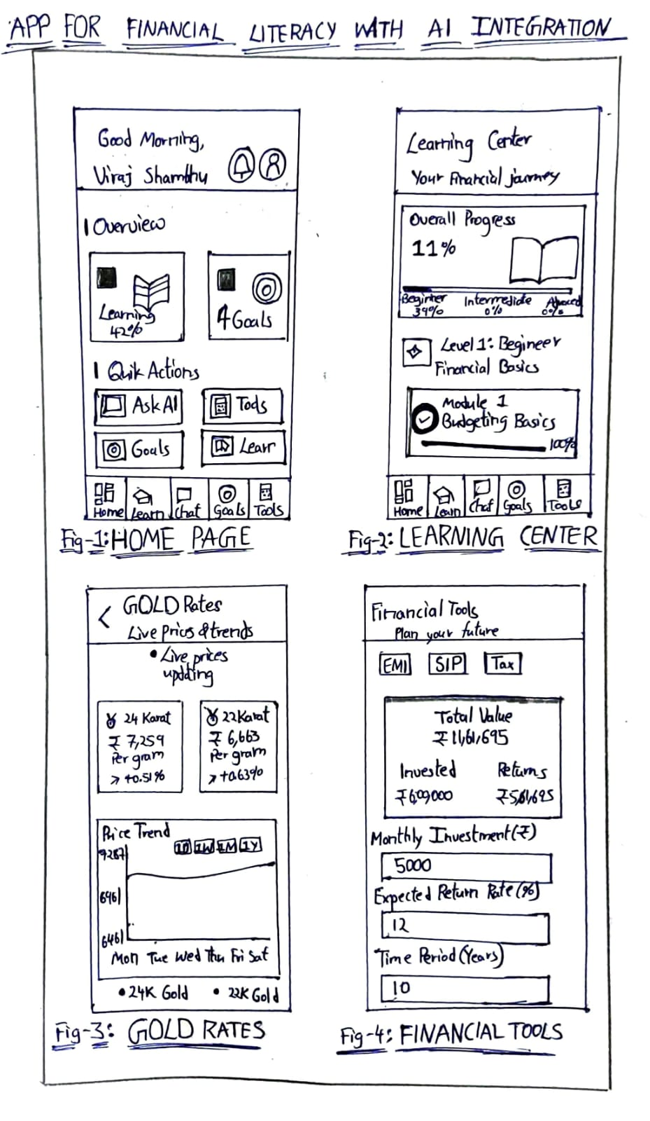

3D Design:
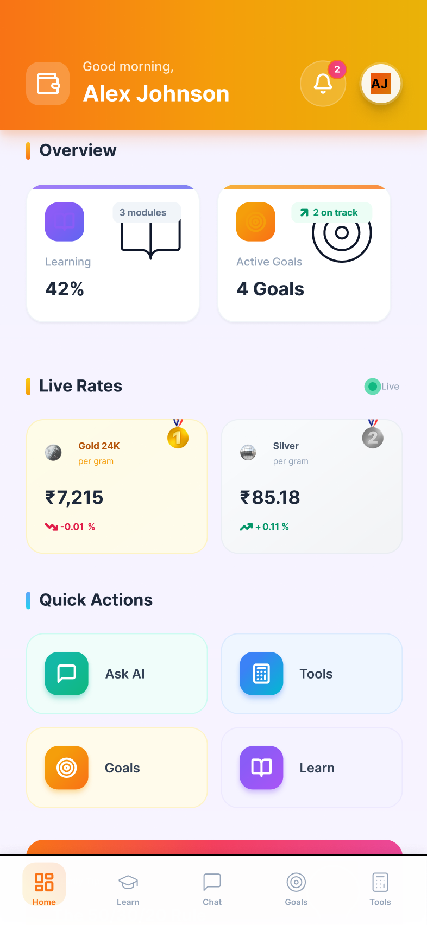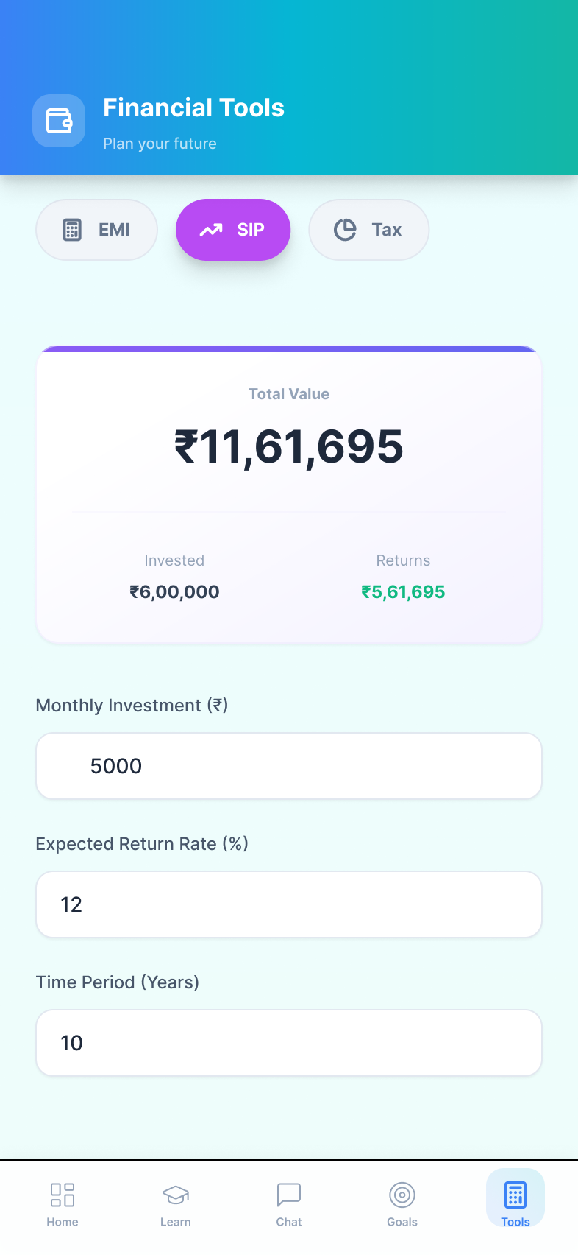

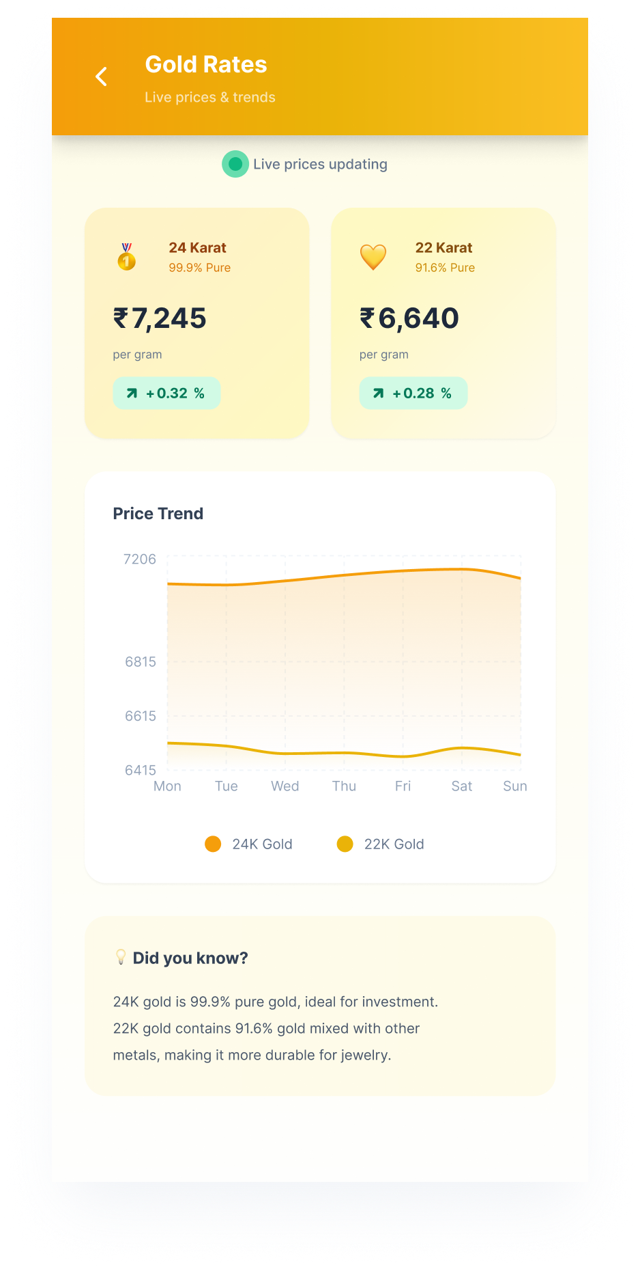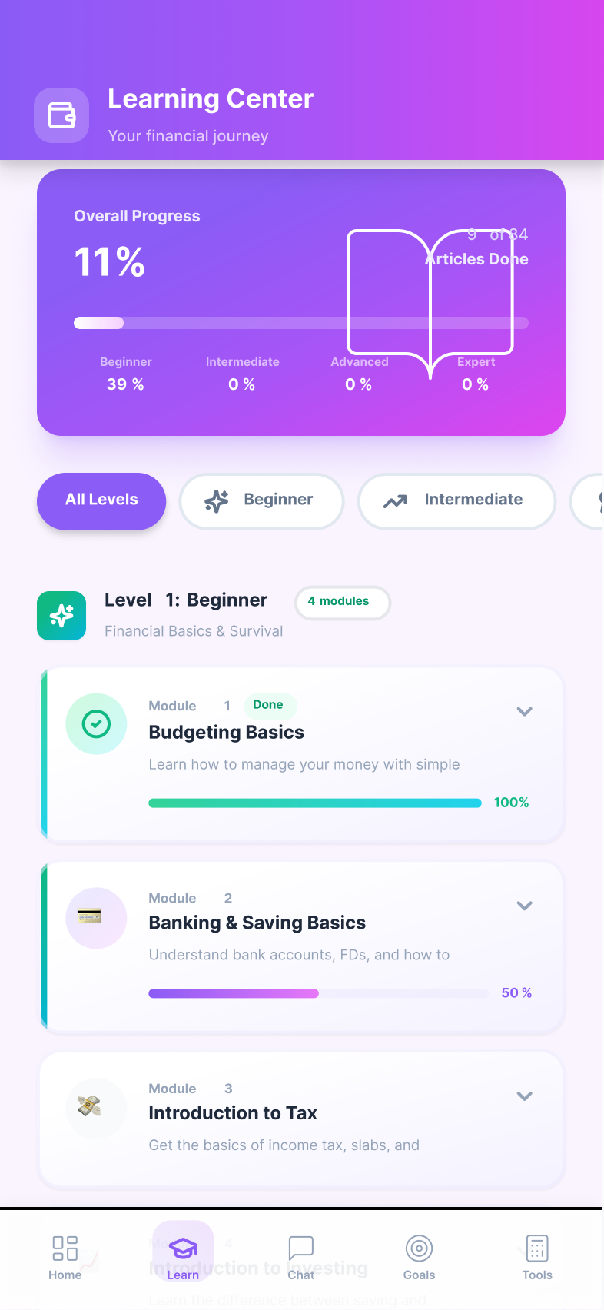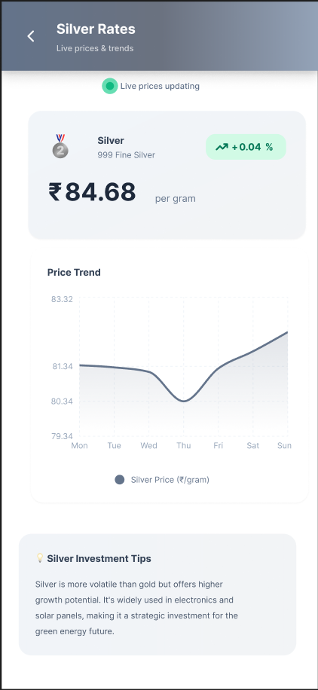

FUNCTIONAL PROTOTYPE

1. Financial Query Processing & AI-Based Guidance
- Users can type or speak financial questions related to budgeting, savings, loans, investments, taxes, or general financial concepts.
- The AI-powered NLP engine identifies user intent, extracts finance-related terms, and generates simple, accurate explanations using a curated financial knowledge base.
- The chatbot responds in beginner-friendly language, providing step-by-step guidance, examples, calculations, and visual aids (charts/infographics) when required.

2. User Authentication & Personalized Profiles
- A secure login/sign-up system with encrypted credentials ensures that each user’s financial learning data remains protected.
- Profiles store optional information such as age group, financial goals, income range, spending habits, and preferred learning level (Beginner → Advanced).
- Users can track previous conversations, saved AI explanations, financial calculations, and learning progress through a Progress Dashboard.
3. Financial Assessment & Money-Health Awareness
- The chatbot conducts structured Q&A flows to assess user situations such as overspending, low savings, loan burden, poor budgeting, or lack of financial planning.
- Based on the user’s responses, the system provides explanations, identifies risky financial habits, and suggests safer money practices.

4. Financial Tools, Learning Modules & Emergency Guidance
- The app includes essential financial tools such as EMI Calculator, Savings Goal Tracker, Investment Return Estimator, and Expense Analyzer.
- The learning hub delivers courses, articles and quizzes sections covering personal finance topics in simple language.
- For urgent financial scenarios—unexpected expenses, debt pressure, credit card issues, loan confusion—the app provides quick step-by-step guidance and possible action paths.

5. Response Dashboard & Interaction History
- AI responses appear in structured sections including: concept explanation, examples, calculations, recommended actions, and prevention strategies.
- All interactions, financial reports, assessments, and learning records are stored securely in the History module for future review.

6. Utility Features, Settings & Privacy Controls
- Utilities include Edit Profile, Change Password, Reminders and Notification Controls.
- Users can manage privacy through options like clearing chat history, disabling data collection, or permanently deleting their account.
- All financial-related notes, inputs, and chat data are encrypted end-to-end to ensure complete safety and confidentiality.

7. Testing & Validation of the Prototype
- The prototype was tested for the full user journey: onboarding → home dashboard → financial query input → AI response → tool execution → history saving.
- Real-time AI processing was validated using NLP models integrated via REST APIs built with Python..
- Usability testing confirmed smooth navigation, fast response generation, consistent tool performance, and high clarity of explanations for users of all levels.

IMPACT OF THE PROTOTYPE
The AI-powered financial literacy app improves access to trustworthy financial knowledge, reducing confusion and misinformation among beginners. It empowers users to make better budgeting, saving, and investing decisions by offering instant guidance and practical financial tools. The app promotes financial discipline and early awareness, helping users avoid debt traps, plan their money better, and build long-term financial habits. It supports the global movement toward AI-assisted learning by making financial knowledge accessible to students, working professionals, and individuals with limited financial education. The prototype demonstrates strong potential to transform financial learning by offering personalized guidance, structured modules, and real-time assistance, ultimately enhancing financial confidence and decision-making for all users.

CONCLUSION
The Financial Literacy App with AI Integration provides an accessible and user-friendly platform that enhances financial knowledge for users of all levels. By combining an AI chatbot, structured learning modules, and practical financial tools, it empowers individuals to make confident and informed money decisions. The functional prototype demonstrates smooth performance, accurate guidance, and real-life usefulness across various financial scenarios. With scalable engineering and ethical AI standards, the app shows strong potential for future expansion into fintech services and broader educational ecosystems. Overall, the project delivers a modern and impactful solution that improves financial awareness, daily money management, and long-term financial wellbeing.

